Brittany Puebla
Lab Proposal

Relationship between the ability to taste different concentrations of PTC and the preference of coffee type

Introduction:
The compound phenylthiocarbamide tastes extremely bitter to some people and is tasteless to others. (Sato, et al., 2010) Approximately thirty percent of the population cannot taste phenylthiocarbamide, and these people are known as “non-tasters”. Non-tasters are therefore not sensitive to other bitter tastes. This is the opposite for people who can taste phenylthiocarbamide, or “tasters”, who show less preference for food that exhibits bitterness. (Jepper, 2009) The ability or inability to taste phenylthiocarbamide is an inherited trait that has been shown to correlate with many food preferences in humans. (Kim, 2005) The inability or ability to taste phenylthiocarbamide is governed by the gene TAS2R38, which is member of the T2R family, a gene family of bitter taste receptor genes. (Kim, 2005) The inability to taste phenylthiocarbamide is a result of the mendelian inheritance of the two recessive alleles. (Sato, et al., 2010) Mendelian genetics refers to how heritable traits are passed down to offspring through the concepts of dominance and recessiveness. However, some non-tasters can taste phenylthiocarbamide if it’s in very high concentrations, such as a concentration of 10⁻² M. If one dominant allele for PTC tasting is present, the person will be able to taste phenylthiocarbamide. Mendelian genetics works together with molecular genetics to express a phenotype. Observed heritable traits that are passed down are controlled at the molecular level by amino acids and proteins that allow these traits to be expressed. (Overath, 2011)
For the ability to taste PTC, the molecular level of the gene will determine whether it will be expressed or not. A difference in one nucleotide in the DNA sequence of a gene can encode for a different amino acid. In the case of the TAS2R38 gene, three single nucleotide polymorphisms cause a change in three amino acids, which leads to the two common alleles responsible for PTC tasting. The dominant allele is controlled by the amino acid PAV and produces a functional protein receptor that binds to PTC. Phenotypically, due to the presence of PAV, the individual can taste PTC. The other allele results from a missense mutation and is the recessive allele. This allele is controlled by the amino acid AVI, which produces a nonfunctioning protein receptor that does not bind to PTC. As a result, phenotypically, the person cannot taste PTC. (Overath, 2011)
The TAS2R38 gene is not the only gene that affects taste sensitivity to PTC. Studies have shown that a number of other genetic loci are also responsible for taste sensitivity. (Genick, 2011) It has been found that the taste sensitivity to phenylthiocarbamide is related to the sensitivity of tasting caffeine, which is a bitter substance present in coffee. Coffee contains .003-.004 M caffeine, therefore its bitterness is below the threshold of most non-tasters of phenylthiocarbamide and above the threshold for tasters of phenylthiocarbamide. (Hall, 1974) Besides caffeine, coffee has other bitter substances and depending on the amount of those substances, the caffeine may or may not make a difference. (Hall, 1974) What needs to be explored is whether the ability to taste phenylthiocarbamide in different concentrations affects the preference for different types of coffee. Coffee can be drunk with different amounts of creamer, milk, and sugar to mask the bitter taste of the coffee itself. The question to be asked is whether the preference of the amount of substances in coffee is related to the ability to taste phenylthiocarbamide in different concentrations. The hypothesis is that people who enjoy their coffee with more substances such as creamer, milk, or sugar, which dilutes the coffee, are more sensitive to its bitterness and therefore can taste PTC even in low concentrations. The idea that many non-genetic factors may contribute to food preference and may have more of an influence of dietary choice than genetics should be taken into account (Gorovic, et al, 2011)

Methods:
A sample of 22 students from ages 18-23 will be examined. A survey format will be used to collect the date. There will be three different types of coffee: black coffee with no milk and no sugar, black coffee with just sugar, and coffee with milk and sugar. Each student will taste each type of coffee and indicate the likeness of the coffee on a scale from 1 to 5, 1 being completely enjoyable and 5 being completely not enjoyable. Then they will rate the bitterness of each coffee on a scale from 1 to 5, 1 being not bitter and 5 being completely bitter. There will be three different concentrations of phenylthiocarbamide: one of 10^-4M, 10^-3 M, and 10^-2 M. Each subject will taste each concentration of PTC and indicate whether they can taste it on a scale from 1-5, 1 being that they cannot taste the bitterness at all, and 5 being that they can taste the bitterness completely. All subjects will get an individual survey where they will indicate which type of coffee they preferred out of all 3 types of coffee in the experiment and their coffee drinking habits, such as what type of coffee do they usually prefer, when or during what time do they usually drink coffee, and the reasons they have for drinking coffee.
Results:
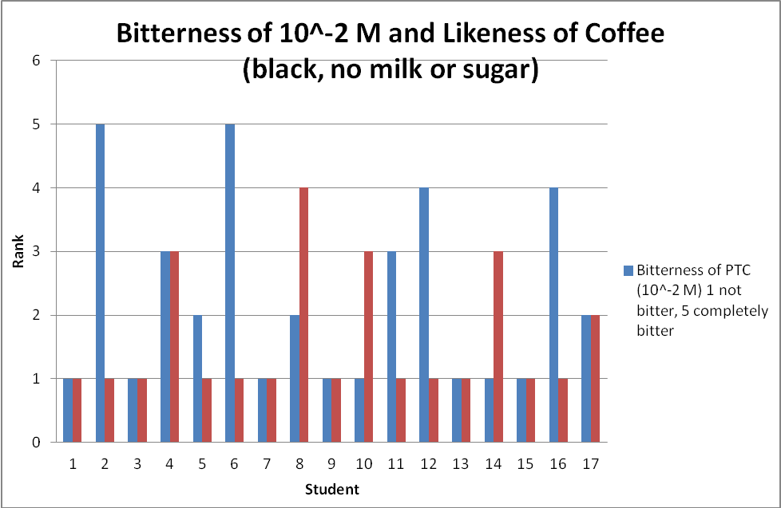
 | PTC 10^-2 M | Coffee (black, no milk or sugar)
Mean | 2.235294118 | 1.588235294
Variance | 2.191176471 | 1.007352941
Observations | 17 | 17
Pearson Correlation | -0.183118958
Hypothesized Mean Difference | 0
df | 16
t Stat | 1.37904611
P(T<=t) one-tail | 0.09342732
t Critical one-tail | 1.745883669
P(T<=t) two-tail | 0.18685464
t Critical two-tail | 2.119905285
PTC (10⁻²M) and Coffee (black, no milk or sugar); Analysis of data using t-Test
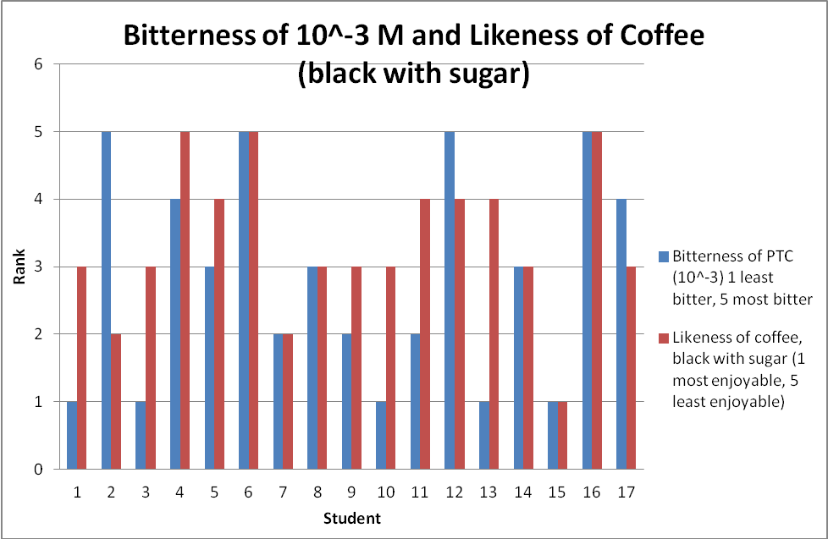
 | PTC 10^-3M | Coffee (black with sugar)
Mean | 2.823529412 | 3.352941176
Variance | 2.529411765 | 1.242647059
Observations | 17 | 17
Pearson Correlation | 0.460362993
Hypothesized Mean Difference | 0
df | 16
t Stat | -1.49224801
P(T<=t) one-tail | 0.077544237
t Critical one-tail | 1.745883669
P(T<=t) two-tail | 0.155088473
t Critical two-tail | 2.119905285
PTC (10⁻³ M) and Coffee (black with sugar); Analysis of data using T-test.
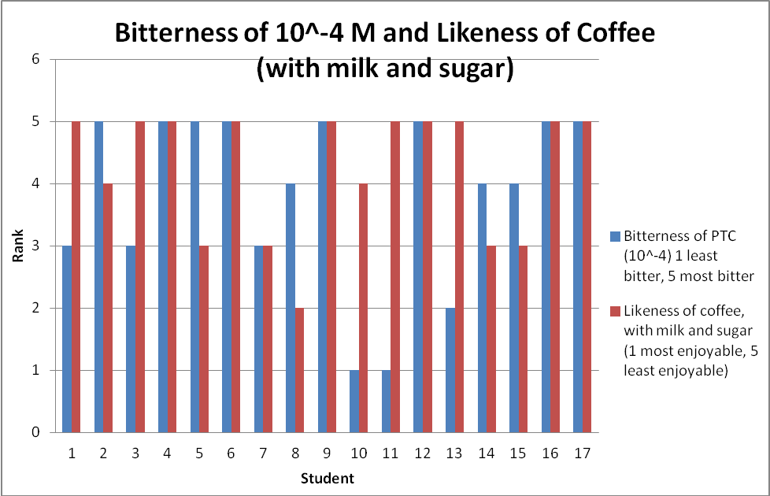
 | PTC 10^-4 M | Coffee (with milk and sugar)
Mean | 3.823529412 | 4.235294118
Variance | 2.029411765 | 1.066176471
Observations | 17 | 17
Pearson Correlation | -0.012496876
Hypothesized Mean Difference | 0
df | 16
t Stat | -0.959264194
P(T<=t) one-tail | 0.175849122
t Critical one-tail | 1.745883669
P(T<=t) two-tail | 0.351698244
t Critical two-tail | 2.119905285

PTC (10⁻⁴ M) and Coffee (with milk and sugar); Analysis of Data using t-Test

Discussion:

